Sprint 2

Estimate the crop yield using data analytics

Team Id: PNT2022TMID21314

1.Waterfall: A waterfall chart **shows a running total as values are added or subtracted**. It's useful for understanding how an initial value (for example, net income) is affected by a series of positive and negative values. The columns are color coded so you can quickly tell positive from negative numbers.

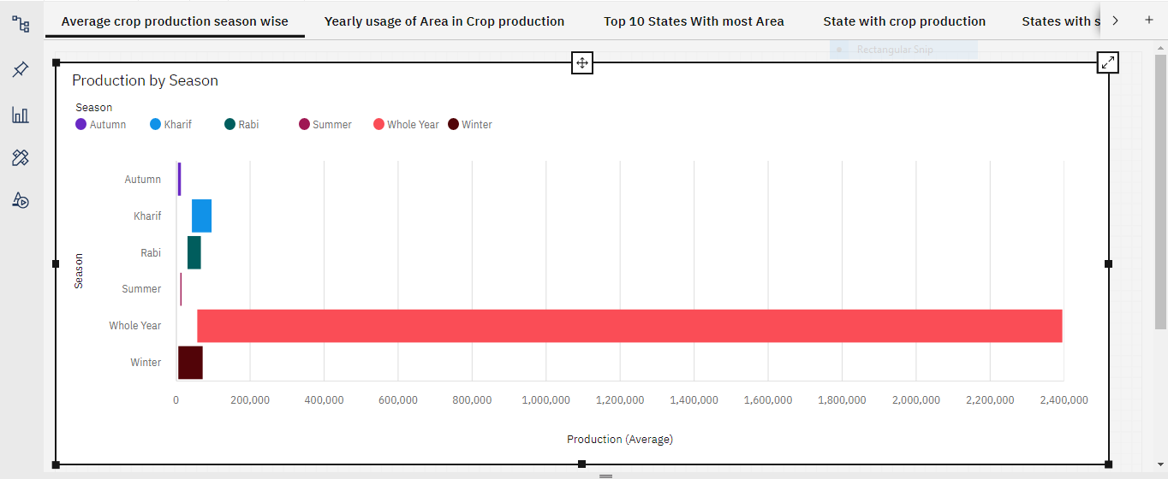

2.Line chart:

A line chart is **a graphical representation of an asset's historical price action that connects a series of data points with a continuous line**. This is the most basic type of chart used in finance, and it typically only depicts a security's closing prices over time.

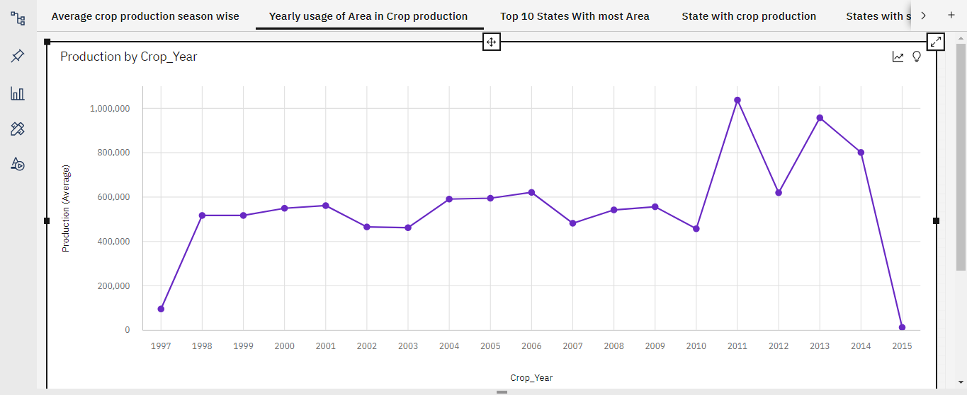

3.Bar graph:

X-axis: State_name

Y-axis: Area(average)

A bar graph is a graphical representation of information. It uses bars that extend to different heights to depict value. Bar graphs can be created with vertical bars, horizontal bars, grouped bars (multiple bars that compare values in a category), or stacked bars (bars containing multiple types of information).

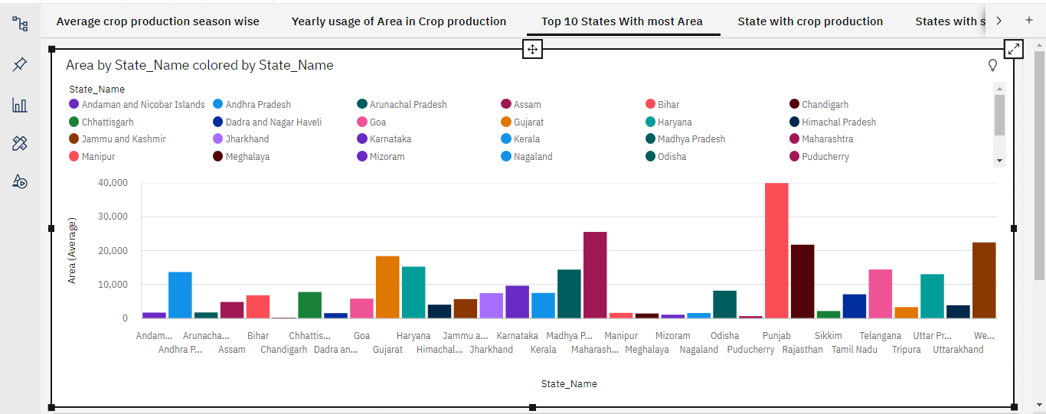4. Geographic map:

A geographical map represents an image of the earth's surface following a specific focus and / or purpose (e.g. topographic, geological). One of the main challenges in creating maps is that the complexity of the earth's surface can't be exactly represented on a map. Maps therefore are an approximation of reality only.

Here, each color represents each state.  
